Project Title: SIGNS WITH SMART CONNECTIVITY FOR

BETTER ROAD SAFETY PROJECT DESIGN PHASE-I - SOLUTION FIT TEMPLATE Team ID: PNT2022TMID48096

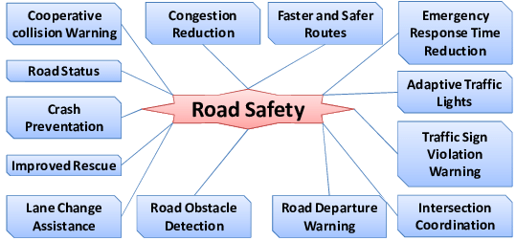

**Motorist,passenger,public transportation operator or User, truck driver bicyclist, Motorcyclist, or pedestrians including a Person with disabilities are considered as**

**Customers.**

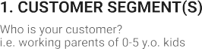

**Drive in the prescribed speed limits on the**

**Various roads. Always remember that “speed Thrills but kills”. Always put on helmets, seat belts and other safety equipments before driving a bicycle/ motor /vehicle.**

**Customer poses risks to each other. Young people Faces the largest risk in traffic. Pedestrians, cyclists, Moped riders and motorcyclists have a higher**

**injury Rate per kilometer of travel than other road Users.**

* **ALWAYS WEAR A HELMET**
* **DRIVE WITHIN THE SPEED LIMITS**

**ALWAYS GIVE AN INDICATOR WHILE**

* **CHANGING LANES**.
* **WORK STRESS /TIME PRESSURE**
* **NEW TECHNOLOGY**
* **OVER CONFIDENCE**

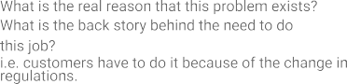

|  |  |  |  |  |  |  |  |  |  |  |
| --- | --- | --- | --- | --- | --- | --- | --- | --- | --- | --- |
|  | **3. TRIGGERS TR**  **1. Frequent traffic jams.**  **2. Too many vehicles on the roads.**  **3, Medle of traffic on the roads.**  What triggers customers to act? i.e. seeing their neighbour installing solar panels, reading about a more efﬁcient solution in the news. | **10. YOUR SOLUTION SL**   * + **USE NEW TECHNOLOGY SUCH AS SMART TRAFFIC AND TRAFFIC**   **CONTROL SYSTEMS**   * + **ARTIFICIAL INTELLIGENCE**   + **USE OF AUTOMATIC TECHNOLOGY** | 1. **CHANNELS OF BEHAVIOUR CH**      |  |  | | --- | --- | | **ONLINE** | **OFFLINE** | | **NEW TECHNOLOGY** | **DON’T DRINK AND DRIVE** | | **INEFFECTIVE**  **SUPERVISION** | **DON’T USE MOBILE WHILE DRIVING** | |  |
| **4.EMOTIONS ;**   |  |  | | --- | --- | | **BEFORE** | **AFTER** | | **Aggressiveness** | Enabling the driver to be more productive | | **Anger** | Happy | | **Stress** | More comfort & safety | |